Opening PDF Files in New or Updated Chrome Browser
A recent update to Google Chrome disabled the use of 3rd party plug-ins. If you are having problems viewing PDF files in the Chrome browser, follow the steps below to enable the Acrobat PDF plugin.

- Ensure you have Adobe Acrobat Reader 8 or higher (8, 9, X, XI, DC).
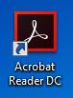

- Open Google Chrome and type “chrome://flags/#enable-npapi” into the address bar and hit enter.
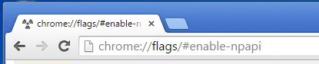

- Click Enable where highlighted below.
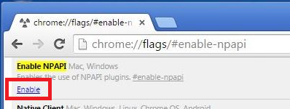

- At the bottom of the browser, click the Relaunch Now button.
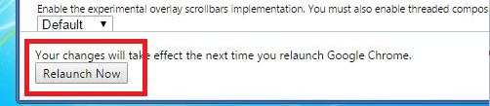

- Type “chrome://plugins” into the address bar and hit enter.
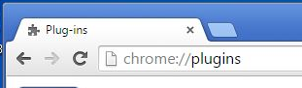

- Click Disable on Chrome PDF Viewer, then click Enable on Adobe Reader.
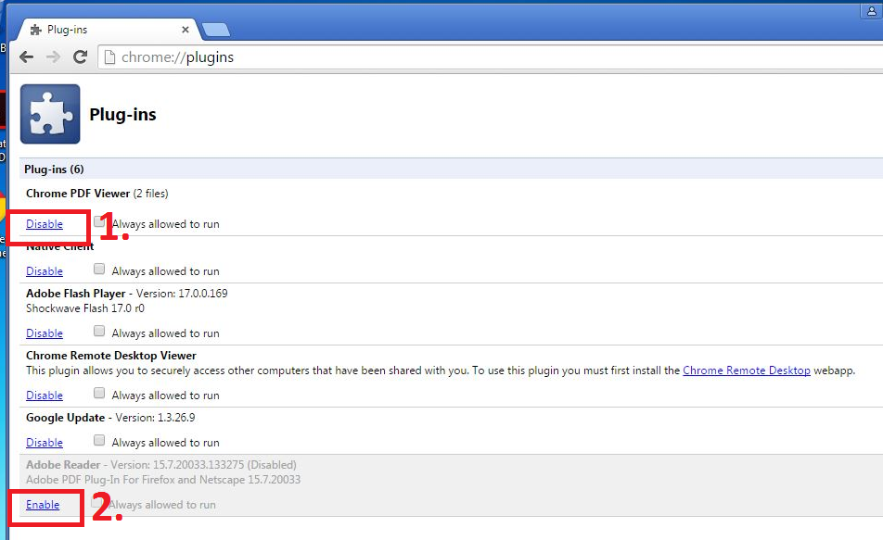

- Navigate to the problematic PDF.
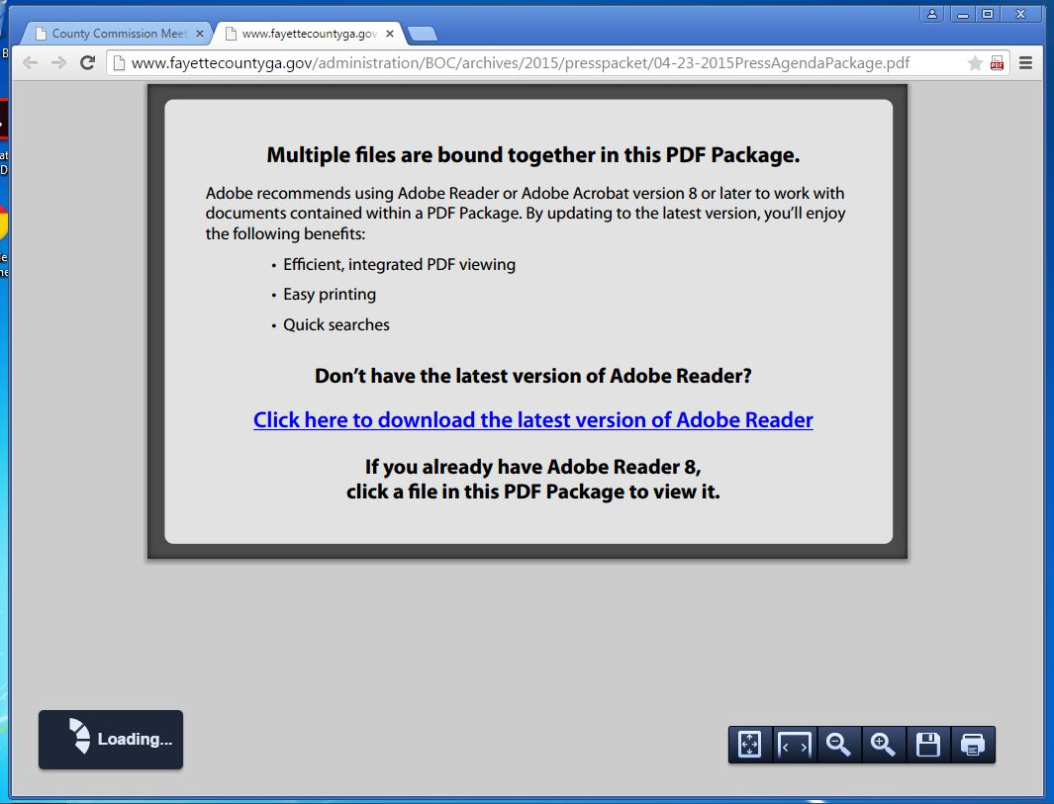

- Click the PDF icon labelled 1. below, then click “Open in Acrobat Reader”.
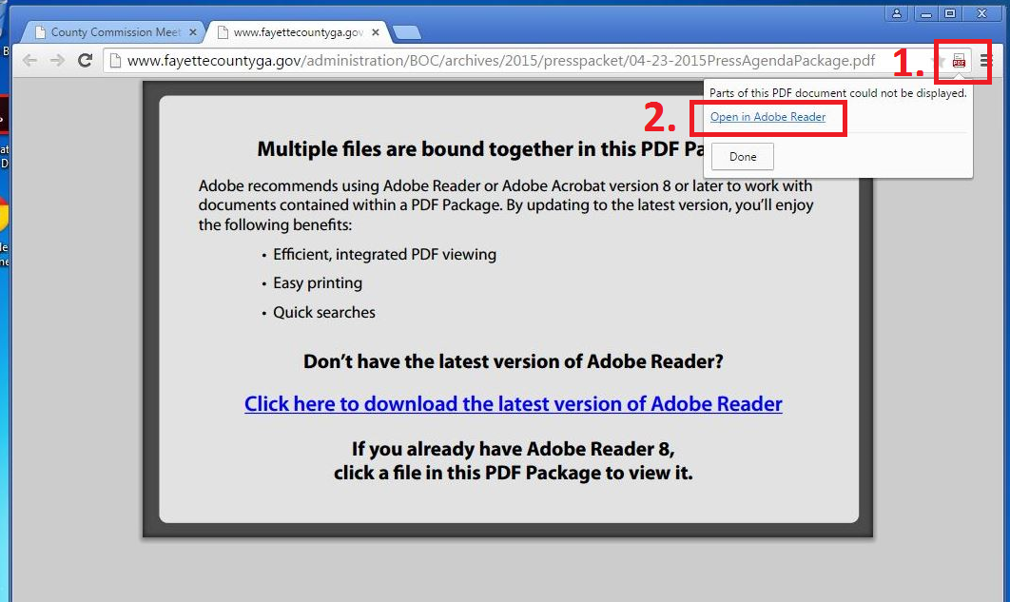

- Click the puzzle piece with the red X on it highlighted below. Then select “Always allow plug-ins on…” and click the Done button.
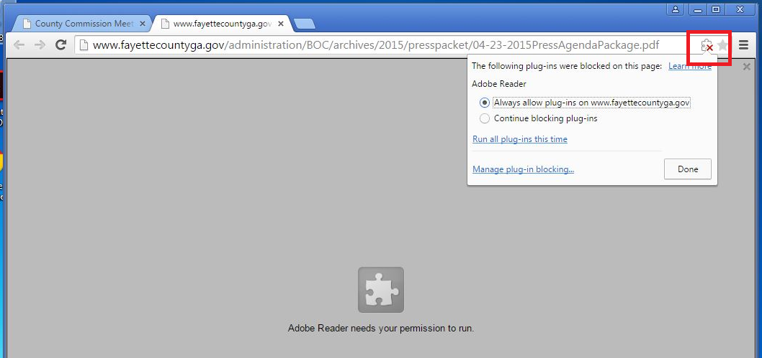

- PDF files should now open correctly in Chrome.
